**Check in:** The kids have been going to school in person for about 1 month now. Ask the kids: What is their favorite part of going to school in person? What do they not like? What is the difference between online school and in person school?

**Homework help**: Ask the students to share their screen and show you what they are working on. If you are having trouble getting the students to share below are some questions you can ask to stimulate the conversation on what they are learning and what they may need help on.

Ask questions like:

* What homework did you have this week?
* Can you show me you English/math/ history…?
* Can you tell me about what you did in history/English/ math/ science this week?
  + Can you explain it to me?

***NOTE****: I always make 2-3 extra rooms. If you need to do some one on one homework help send me a text and I can move you or hit call host. You can also go back to the main room with the student though there may be other people in the main room.*

**Brain break game**: Play Simon says with the kids

* Jump up and down
* Turn on /off your camera
* Write ----- in the chat. Banana, ice-cream, book…..
* Raise your hand
* Change your name to your last name

**Factors and multiples**:

**Factors** are all the numbers that can multiply by another number to reach the goal number. For example: The factors of 10 are 10,5,2, and 1.

Play this Kahoot! to practice Factors: <https://kahoot.it/challenge/02953079?challenge-id=e21d906a-1678-4c6e-a9ee-5f26c1dc0f29_1619116573554>

Game PIN: **02953079**

Practice:<https://www.khanacademy.org/math/cc-fourth-grade-math/imp-factors-multiples-and-patterns/imp-math-patterns/v/figuring-out-days-of-the-week>

Video: <https://youtu.be/S7CLLRHe8ik>

Practice: <https://www.khanacademy.org/math/cc-fourth-grade-math/imp-factors-multiples-and-patterns/imp-math-patterns/e/math-patterns>

**Games**: ‘hang man’ pop the balloons

* Draw 6-9 balloons on the white board. Every time a student guesses the wrong letter write that letter in a balloon. This means the balloon has ‘popped’ continue until the students guess the word or all the balloons are popped.
* If you want you can have the kids guess the letters.

**5/5 Equity and fairness**- Everyone gets what they need to be successful.

Ask the students “What does it mean to be fair?” Let students give examples. (Everyone gets the same thing, we all get one cookie, all children get the same amount of time to play on dad’s phone) If students are struggling coach them along with examples. (Everyone in the class gets to go on reses for the same amount of time, everyone get 1 cookie, and everyone gets the same time on a test)

Coach: ‘I want to tell you about a new word. It’s called “Equity”. Equity means that “Everyone gets what they need to be successful.”

Ask the students, ‘Do you have any little brothers or sisters?’ (Students answer yes or no. if they answer no ask if they have older siblings)

* Are all of your brothers and sisters the same heights?
* Are you all able to reach the top shelf in your apartment’s kitchen?
* If you are shorter do you need to stand on a chair or get help from a big brother or sister to get something from the top shelf? This is equity. Because not everyone is the same we all need different things to help us reach our goals.

Let’s look at this picture. What is different between the two pictures? (The kids are standing on more boxes, they all can see the game and the other picture can’t)

* What different things do they need to be able to see the soccer game clearly?
* What different thing do your friends need to succeed? (Help with translating….)

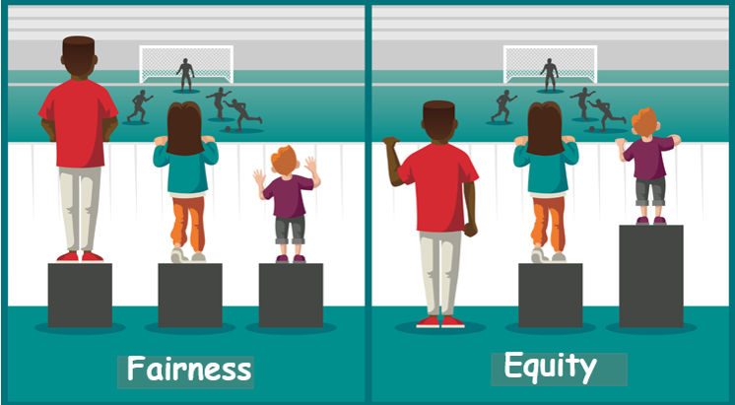

**Wrap up** finish working on what you are working on or transition to the game.